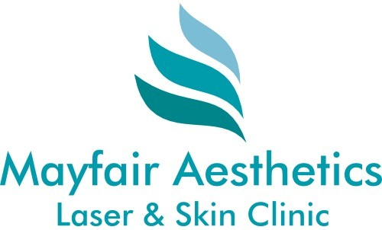

Laser Hair Removal – Follow Up Visit Medical Questionnaire
Please read and complete the following questionnaire and declaration at least 24 hours prior to your appointment. Various medications and medical conditions will prevent you from having laser hair removal. To avoid an unnecessary journey, please ensure you answer all questions to the best of your knowledge. Our team will check the form 24 hours prior to your appointment and will contact you to reschedule if any of the answers you provide warrant doing so.

Coronavirus (COVID-19) questions
Have you tested positive for COVID-19 within the last 10 days?
If yes, when was the test and what was the result?
Do you currently have or have experienced any of the following symptoms in the last 10 days?
High temperature, (greater than 38 Celsius), respiratory problems, shortness of breath, loss of taste/smell, persistent cough, unexplained fatigue/malaise/muscle aches, chills, flu like symptoms, stomach upset or diarrhoea.
Have you had the covid or flu vaccine in the last 14 days?

General medical questions
Have you changed medications or started using any new medications since your last visit? Many medications such as antibiotics will require a 2 week wait before continuing treatment after you finish taking the medication?
If yes, please provide details:
Various activities and treatments may prevent us from treating you. Please write YES next to any of the below statements that apply to you today:
I have had a surgical operation in the last 6 weeks
I have been exposed to sunshine or an electric sun bed in the last week to the areas I will be treating.
I am sunburned or the skin is red, sore or peeling in the area to be treated.
I have been sunburned in the last 6 weeks in the area to be treated
I currently have fake tan on the areas I will be treating
I have used or am planning to use a numbing cream such as Elma.
I have removed hair from the treated area with a method other than shaving in the last 6 weeks. (Plucking, threading, tweezing, upilating, waxing, bleaching, hair removal cream).
I am pregnant.
I have had a chemical peel or microdermabrasion treatment in the area to be treated area in the last 2 weeks.
Please note - Mayfair Aesthetics operates a strict cancellation policy for all appointment bookings. If you fail to attend or cancel or attempt to move your appointment without a minimum of 24 hours notice, you will lose this part of your course. This includes moving an appointment due to late arrival, sunburn, fake tanning, failure to properly shave or medications. We send confirmation and reminder emails and a reminder text prior to all bookings. Please check these carefully and ensure we have your correct email address (see above). Please mark Mayfair Aesthetics as a safe sender to prevent our messages going to your junk mail. The booking system pauses for maintenance and updates from time to time so please make a note of any appointments in your diary or planner and do not exclusively rely on reminder emails.
REMINDER - Please ensure that you thoroughly and smoothly shave all body areas to be treated with laser hair removal around 8 hours prior to your appointment. If you arrive unshaven or poorly shaved, the treatment will not be able to be carried out.
By checking here and signing below you are agreeing that you have read and understood the points above, have answered the questions contained herein to the best of your knowledge and that you are consenting to the use of your electronic signature in lieu of an original signature on paper.
Signature: Agathe Constanty
Date: 10/06/2026

